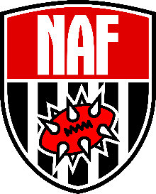
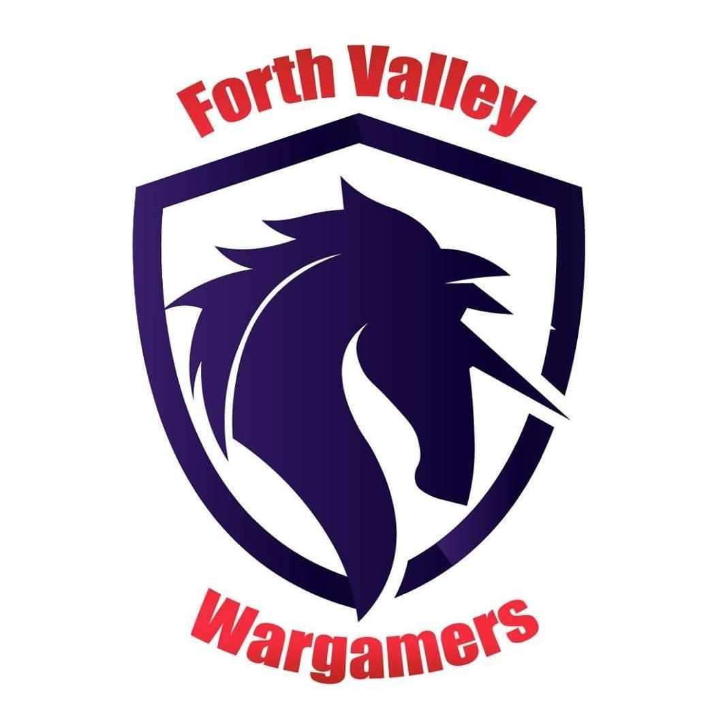
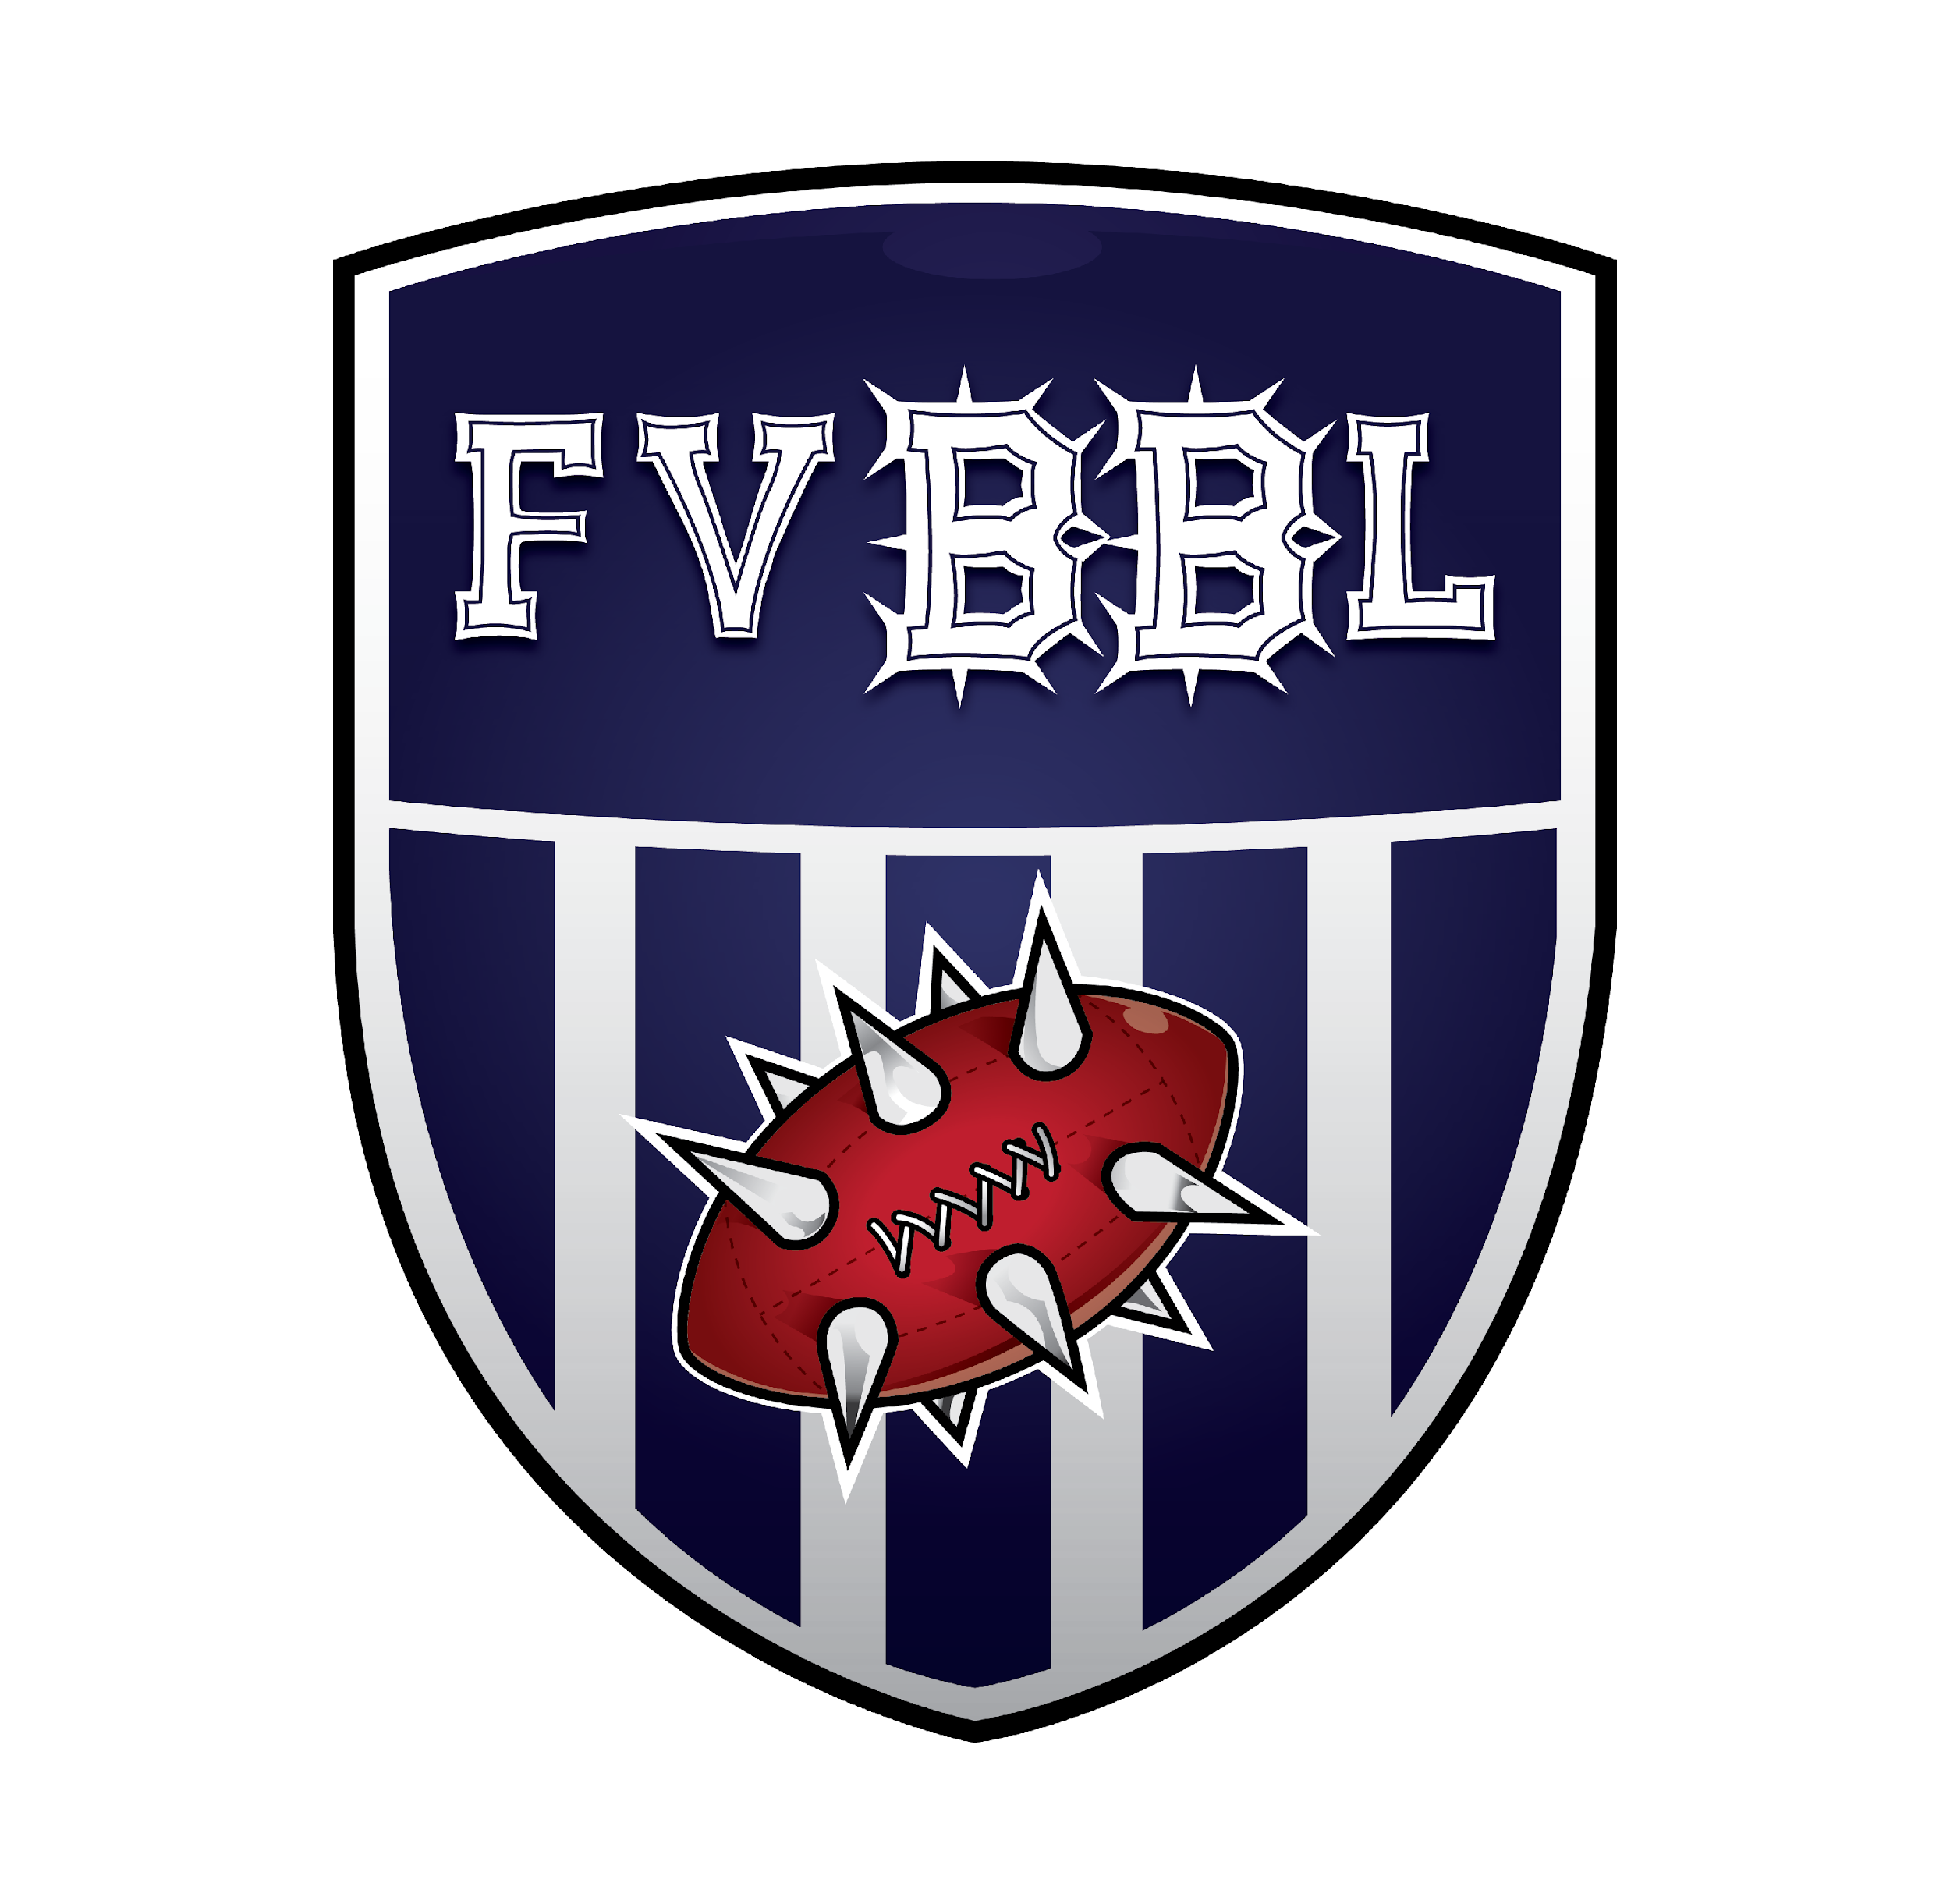

Forth Valley Wargamers, in association with Forth Valley Blood Bowl League Proudly Present

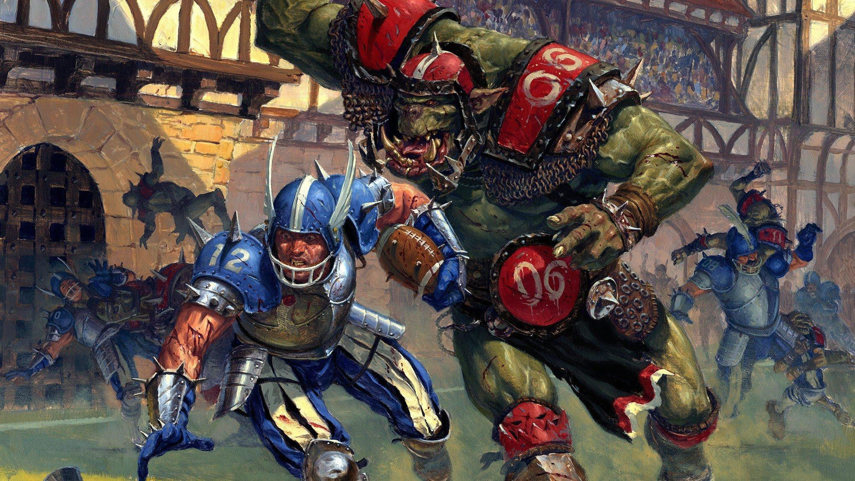KELPIE CUP 2024
SPONSORED BY
SPONSORED BY

Welcome to Blood Bowl’s famous Kelpie Cup, proudly brought to you in association with the Forth Valley Blood Bowl League (FVBBL).

This pack should contain everything that you need to compete in Kelpie Cup 2024, but the Commissioners can be reached at:

Email: forthvalleywargamers@gmail.com.
Discord: https://discordapp.com/channels/689202029884735524/1102551017184309401

What, When, Where and How Much?

Kelpie Cup 2024 will take place at our regular club venue, the Elgin Park Centre in Falkirk, on the 16th-17th of November 2024. It will consist of five games of Blood Bowl 2020 Season 2.

The times for the event are detailed below. The tournament will cost £35 (per Coach) and includes lunch on both days. For an additional £5, non-NAF coaches can register with the NAF.

Tickets are available to buy via the club webstore: https://forthvalleywargamers.fws.store/product/bloodbowl-kelpie-cup-2023

The event location is:

Elgin Park Centre,
Elgin Place,
Falkirk
FK1 1QN

Parking: we have limited on street parking spaces near to the venue, but there is ample parking close to the venue (https://www.falkirk.gov.uk/services/roads-parking-transport/streets-parking/car-parks.aspx#falkirktowncentre-shortstay). The club is also well connected to public transport, by train and bus.

Kelpie Cup 2024: Schedule

Day 1 | Day 2
09:00 – 09:45 Registration, Coffee & Doughnuts | 09:00 – 09:45 Registration, Coffee & Doughnuts
09:45 – 12:00 Game 1 | 09:45 – 12:00 Game 4
12:00 – 12:45 Lunch | 12:00 – 13:00 Lunch (Best Painted Voting)
12:45 – 15:00 Game 2 | 13:00 – 15:15 Game 5
15:30 – 17:45 Game 3 | 15:30 – Finish Award Ceremony

What You’ll Need

- Your painted and based Blood Bowl team
- Dice
- A pitch
- The core rules for Blood Bowl
- Any relevant supplements and FAQs
- This Gaming pack.
- A mobile device (phone/tablet) with mobile data for access to the TourPlay app/website. The venue also has WiFi and the password can be provided.

Important Information for Coaches

Team Building

- Kelpie Cup 2024 uses Tourplay for roster creation and tournament management.
- Each team has a total of 1,150,000gp to spend on roster creation and must hire a minimum of 11 players. Any unspent cash at roster creation will be lost and all teams will be considered having the same Current Team Value (CTV) for the purpose of inducements and prayers to Nuffle.
- Cash given is also used to buy side-line staff.
- Kelpie Cup 2024 is a resurrection tournament, so no SPP is gained, and injuries, casualties or deaths do not carry forward to subsequent matches.
- Undead, Vampire, Necromantic and Nurgle teams are allowed to apply the Masters of Undeath and Plague Ridden special rules. Players added to a team roster through a game as a result of those special rules are removed from the roster at the end of that game.
- Teams must consist of a minimum of 11 players and a maximum of 16 players, including star players.
- Star players can only be induced after 11 regular players have already been rostered.
- Star players can’t be given extra skills from the team’s skill budget.
- If both opposing teams are fielding the same star player in a game, both star players are allowed to play.

Permitted Inducements

- 0-1 Halfling Master Chef (300k, or 100k for Halfling teams)
- 0-2 Bloodweiser Kegs (50k each)
- 0-6 Assistant Coaches (10k each)
- 0-12 Cheerleaders (10k each)
- 0-3 Bribes (100k each, or 50k each for ‘Bribery and Corruption’ Teams. In addition, Bribes cannot be taken by any Team which has a Player that starts with, or is given, the ‘Sneaky Git’ Skill. Bribes gained from the ‘Get The Ref’ kick-off result are allowed as normal.)
- 0-2 Wandering Apothecaries (100k each)
- 0-1 Mortuary Assistant (100k)
- 0-1 Plague Doctor (100k)
- 0-1 Riotous Rookies (100k)

All other inducements including Star Players are not permitted unless indicated by the Tier Restrictions below.
Team Tiers and Skill Sets

Teams are separated into tiers based on their inherent ability to perform well at Blood Bowl, either as a result of the basic stats of the players in that team, or the starting skills those players have, and therefore are offered Tier-specific skills packs (A to D)

All teams are permitted to stack two Primary Skills on a maximum of one single Player at the cost of one Secondary Skill. This can only be done once. Teams which do not have the option of a Secondary Skill cannot stack skills.

Examples:
- A Dwarf Coach selects Skill Pack A for their team. As this skill pack does not include the option of a Secondary Skill, they cannot stack two Primary Skills onto any players.
- A Wood Elf Coach selects Skill Pack B for their team. This skill pack allows for 4 Primary Skill and 1 Secondary Skill. The Coach may select to use the Secondary Skill to assign an additional Primary Skill to a player who already received one of the 4 Primary Skills available.
- A Nurgle Coach selects Skill Pack B for their team. This pack allows for 5 Primary Skills and 2 Secondary Skills. The Coach elects to use one of the Secondary Skills to assign an additional Primary Skill to a player who already received one of the 5 Primary Skills available. He cannot choose to use the other Secondary Skill to assign a Primary Skill to a player who already received one, as only a single player may receive an additional Primary Skill in this manner. He must use the remaining Secondary Skill to assign a skill to a player who has not yet been assigned a skill.

Teams able to assign a player a Secondary Skill may always choose to assign a Primary Skill instead and all additional skills must be clearly listed on your tournament roster.
For Skill packs which allow star Players, the following Star Players have an additional skill cost as specified below.:
Star Player | Skill Cost
Morg’N’Thorg | 3 Primary Skills
Griff Oberwald | 3 Primary Skills
Deeproot Strongbranch | 2 Primary Skills
Hakflem Skuttlespike | 2 Primary Skills
Kreek Rustgouger | 2 Primary Skills
Bomber Dribblesnot | 2 Primary Skills
Wilhem Chaney | 1 Primary Skill
If the Team does not have enough skills available in the chosen skill pack to pay the above skill cost, that star Player cannot be taken.

Tiers

Tier 1 | Chaos Dwarves, Dark Elves, Dwarves, Lizardmen, Shambling Undead, Underworld Denizens.
A. 6 Primary Skills
B. 4 Primary Skills + 1 Secondary Skill
C. 3 Primary Skills + Access to 1 Star Player

Tier 2 | Amazons, Norse, Orcs, Skaven, Wood Elves.
A. 7 Primary Skills
B. 5 Primary Skills + 1 Secondary Skill
C. 4 Primary Skills + Access to 1 Star Player

Tier 3 | High Elves, Humans, Necromantic Horror, Tomb Kings, Elven Union, Vampires.
A. 7 Primary Skills + 1 Secondary Skill
B. 5 Primary Skills + 2 Secondary Skills
C. 5 Primary Skills + Access to 1 Star Player

Tier 4 | Chaos Renegades, Khorne, Old World Alliance, Slann.
A. 8 Primary Skills + 1 Secondary Skill
B. 6 Primary Skills + 2 Secondary Skills
C. 6 Primary Skills + Access to 1 Star Player

Tier 5 | Black Orcs, Chaos Chosen, Imperial Nobility, Nurgle.
A. 8 Primary Skills + 2 Secondary Skills
B. 6 Primary Skills + 3 Secondary Skills
C. 6 Primary Skills + Access to 1 Star Player
D. 4 Primary Skills + Access to 2 Star Players

Tier 6 | Goblins, Ogres, Halflings, Snotlings.
A. 9 Primary Skills + 1 Secondary Skill
B. 7 Primary Skills + 2 Secondary Skills
C. 7 Primary Skills + Access to 1 Star Player
D. 5 Primary Skills + Access to 2 Star Players

TourPlay

We will be using the TourPlay.net website and app to administer this year’s tournament. As a Coach, this means that your roster and the results of your matches during the tournament will be entered using TourPlay. The Tournament Commissioners also have the ability to submit results on your behalf in the event of technical issues.

Link to Kelpie Cup 2024 TourPlay Tournament -

Miniatures
Miniatures representing Players are to be painted and based to tabletop standard.

Coaches should ensure they have a system to define skills and positional players and that both Coaches understand that system prior to kick off.

Scoring & Schedule  The tournament shall have five rounds. The draw will be random in the first round and Swiss thereafter for match-ups.  Coaches will be asked to record significant stats from the match and verify with the opposing Coach.  Scoring will be awarded as shown in the table, opposite. | Result | Points
 | Win | 30
 | Draw | 15
 | Loss | 3
 | Loss by 2+ TDs | 0
 | Concession | -5
 | Score 3+TD | +1
 | Bonus Point: 3+CAS | +1

Tiebreakers will be based on the match data shown opposite.  Placings  The Kelpie Cup ‘24 awards open to Coaches are:  - 1st Place  - Runner-up  - Best Painted Team  - Most Touchdowns  - Most Casualties  - Stunty Cup  - Wooden Spoon | Tiebreak Order | Tiebreakers
 | 1st Tiebreaker | Net TDs
 | 2nd Tiebreaker | Net CAS (only casualties which would award SPP will be counted)
 | 3rd Tiebreaker | Opponent score
 | 4th Tiebreaker | Head-to-Head
 | 5th Tiebreaker | Random dice roll of 2D6

Timekeeping
All games will have a 2 hour 15 minute time limit. At full-time, all Coaches are required to put down dice and submit the results to the Commissioner. If a Coach suspects that their opponent is wasting time, they are to call a Commissioner immediately.

